ARANMORE CATHOLIC COLLEGE

3A3B CHEMISTRY - 2014

TEST: ORGANIC CHEMISTRY

**NAME: __________________________________________ DATE: 22 Sept 2014**

**Test Score**

## INSTRUCTIONS

**/50**

1. Time Allowed: 50 minutes

2. Total marks: **50 marks**

4. All questions are to be answered on the question paper.

5. A Chemical data sheet is provided.

6. Graphics calculators are not permitted.

**Section 1 MULTIPLE CHOICE [10 Marks]**

1. Which of the following would not be expected to decolourise an acidified potassium permanganate solution?
2. CH3OH
3. CH3CH2OH
4. CH3CH2CHO
5. CH3COCH3
6. Which of the following structures represents a tertiary alcohol?
7. (CH3)3COH
8. CH3CH2CHOHCH3
9. CH3CH2CH2CH2OH
10. CH3CH2CH2C(OH)3
11. A sample of 1-propanol is treated with limited acidified potassium dichromate solution. Which of the following species would not be present in the final mixture?
    1. Cr6+(aq)
    2. Propanal
    3. 1-propanol
    4. Propanoic acid
12. What substances are used in the formation of a polyester like terylene?
    1. An alkene with another alkene
    2. A diamine with a dicarboxylic acid
    3. An alcohol and a carboxylic acid
    4. A diol and a dicarboxylic acid
13. An organic compound is known to have the empirical formula C2H40. It is found to liberate a colourless gas with sodium and does not discolour an acidified potassium permanganate solution. What is a possible name for the compound?
    1. 1,4-butandiol
    2. Ethanoic acid
    3. Ethanal
    4. Ethyl ethanoate

**End of Section 1**

**Section 2: SHORT ANSWER [20 Marks]**

1. Hexane, 2-methylpentane and 2,2-dimethylbutane are structural isomers. Draw the structural formula and give the systematic name of another structural isomer of hexane.

Name: ________________________________

(2 marks)

1. Name a chemical reagent which could be used to distinguish between cyclopropane and cyclopropene.

Reagent: ______________________________

Observation with cyclopropane: ________________________________________________

Observation with cyclopropene: ________________________________________________

(3 marks)

1. Several different isomers are possible for the organic compound of molecular formula C2H4O2. Give the structural formula for the isomers of C2H4O2 described here.
   1. The ester
   2. A molecule containing two OH groups which does not have cis or trans isomers
   3. The trans isomer for a molecule containing two OH groups

(3 marks)

1. Examine the section of polymer molecule shown here. Draw its structural formula and give the IUPAC name for the monomers used to produce it.

O O O O

-C(CH2)4C-O-CH2(CH2)2CH2-O- C(CH2)4C-O-CH2(CH2)2CH2-O…..

Monomer 1:

Name: _______________________________________

Monomer 2:

Name: _______________________________________

(4 marks)

1. Examine the two compounds below. Compound 1 is the naturally occurring flavouring agent

vanillin. Compound 2 is the local anaesthetic procaine. Name the functional groups circled in

these two compounds.

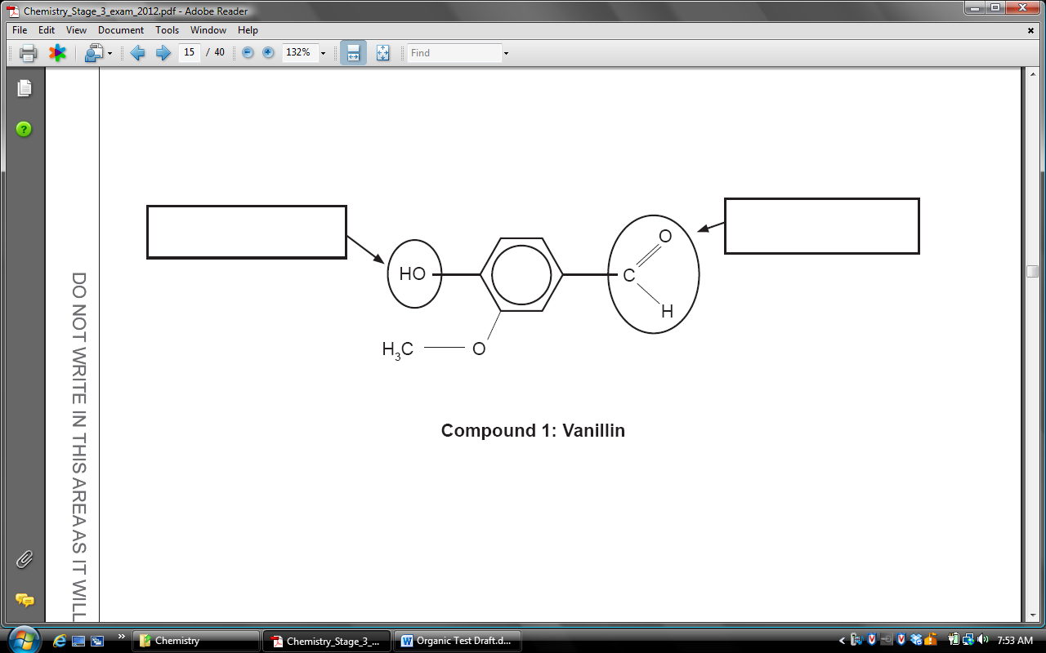

**Compound 1: Vanillin**

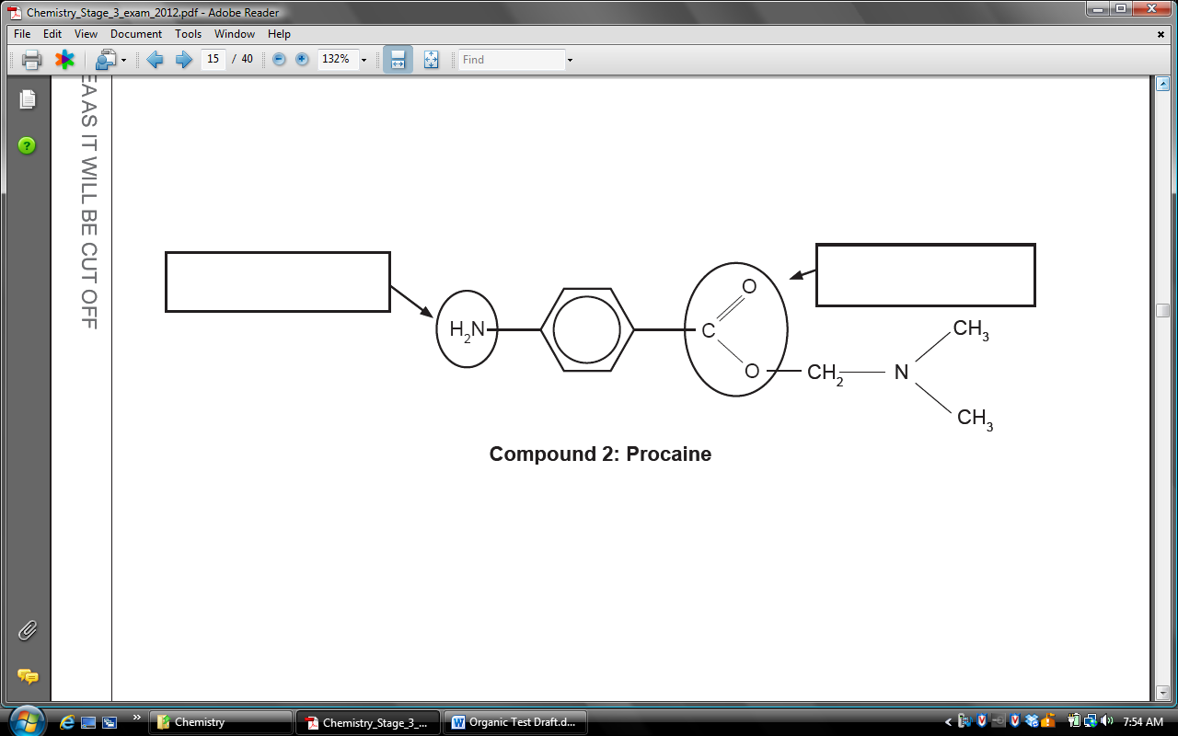

**Compound 2: Procaine**

(2 marks)

1. Organic chloramines are produced by the reaction of an amine with the hypochlorite ion. Give the structure of, and name, the primary amine with 2 carbon atoms. Show all atoms in your structure.

(2 marks)

1. For each of the following pairs of solutions describe a simple **chemical** test that could be used to distinguish between the two substances. State the observation that you would make with each solution.

|  |  |  |
| --- | --- | --- |
| **Pairs of Solutions** | **Describe the Test** | **Observation for each** |
| 2-methyl-2-propanol  and  1-butanol |  |  |
| ethanoic acid  and  ethanal |  |  |

(4 marks)

End of Section 2

**Section 3: Extended Answer Questions [20 Marks]**

1. Soaps and detergents are very useful substances for improving the cleaning action of water. Explain the mechanism by which soaps and detergents are able to remove grease using diagrams to illustrate your explanation. (4 marks)

________________________________________________________________________________________________________________________________________________________________________________________________________________________________________________________________________________________________________________________________________________________________________________________________

1. A student needed to prepare ethanoic acid by the oxidation of ethanol using acidified potassium dichromate solution. What minimum volume of 2.50 mol L-1 acidified potassium dichromate solution is needed to prepare 48.0 g of ethanoic acid by this method?

(4 marks)

________________________________________________________________________________________________________________________________________________________________________________________________________________________________________________________________________________________________________________________________________________________________________________________________________________________________________________________________________________________________________________________________________________________________________________________________________________________________________________________________

1. Citric acid, is a carboxylic acid responsible for the sour taste of lemon juice, contains only carbon, hydrogen and oxygen.

1.383 g of anhydrous (dry) citric acid is burned in dry oxygen to give 1.900 g of CO2 and 0.518 g of H2O.

1. Calculate the empirical formula of citric acid.

(7 marks)

1. 3.84 g of citric acid vaporized at 150 oC was found to occupy 0.700L at 100.0 kPa. Determine the molecular formula of citric acid.

(3 marks)

1. Given that one mole of citric acid reacts with three moles of potassium hydroxide, suggest a structural formula for citric acid.

(2 marks)

________________________________________________________________________________________________________________________________________________________________________________________________________________________________________________________________________________________________________________________________________________________________________________________________________________________________________________________________________________________________________________________________________________________________________________________________________________________________________________________________________________________________________________________________________________________________________________________________________________________________________________________________________________________________________________________________________________________________________________________________________________________________________________________________________________________________________________________________________________________________________________________________________________________________________________________________________________________________________________________________________________________________________________________________________________________________________________________________________________________________________________________________________________________________________________________________________________________________________________________________________________________________________________________________________________________________________________________________________________________________________________________________________________________________________________________________________________________________________________________________________________________________________________________________________________________________________________________________________________________________________________________________________________________________________________________________________________________________________________________________________________________________________________________________________________________________________________________________________________________________________________________________________________________________________________________________________________________________________________________________________________________________________________________________________________________________________________________________________________________________________________________________________________________________________________________________________________________________________________________________________________________________________________________________________________________________________________________________________________________________________________________________________________________________________________________________________________________________________________________________________________________________________________________________________________________________________________________________________________________________________________________________________________________________________________________________________________________________________________________________________________________________________________________________

**End of Test ☺**